Assessment 1-2.1 to 2.4
Course : ITA0404-Statistics With R programming
Name : BoyapatiNandini
Reg no : 192525137
1.Vectors and Assignment
Reciprocal of x
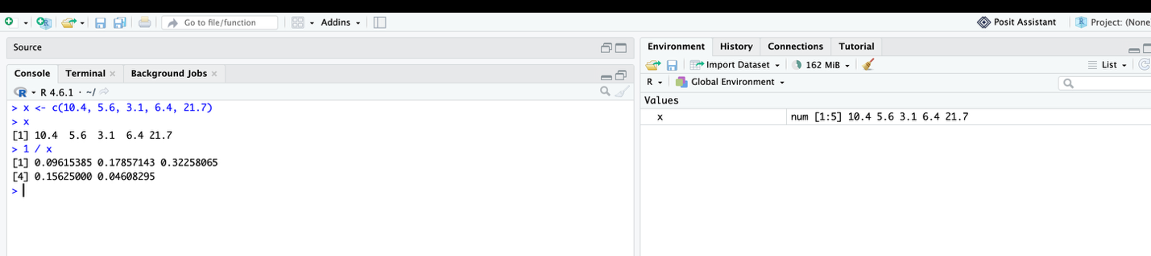
Create y
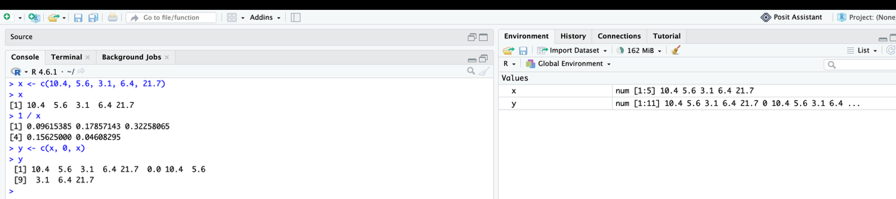

2. Vector Arithmetic
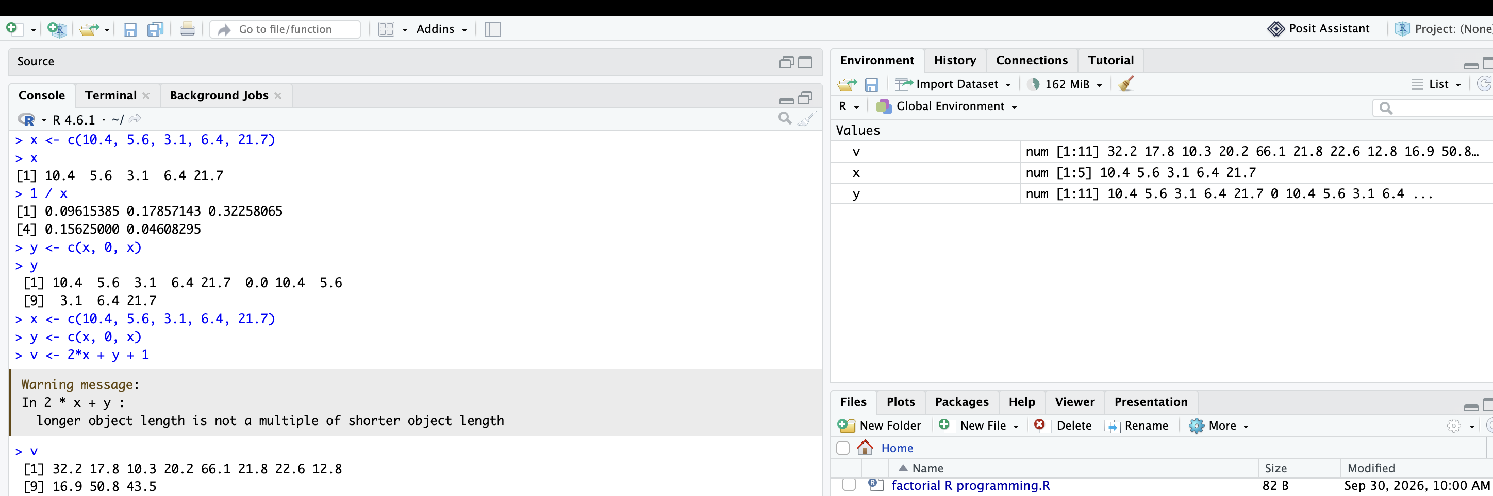
3. Basic Arithmetic Functions
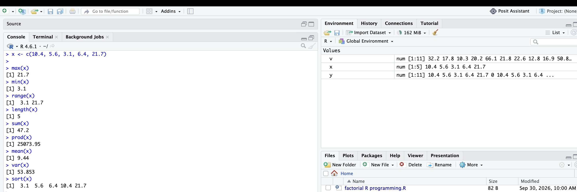
4. Mathematical Functions
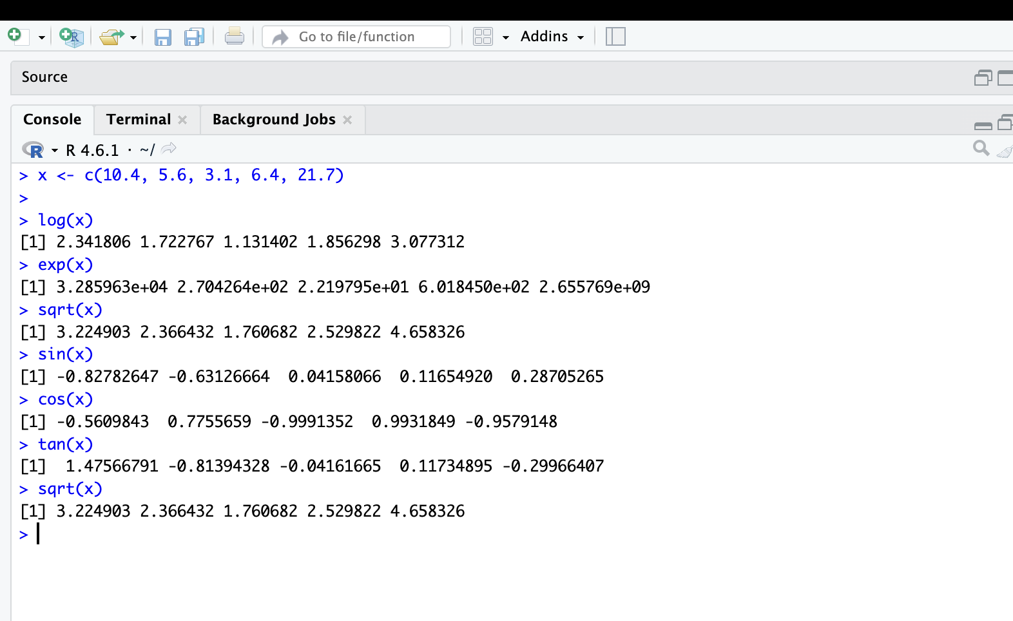

5. Generating Sequences
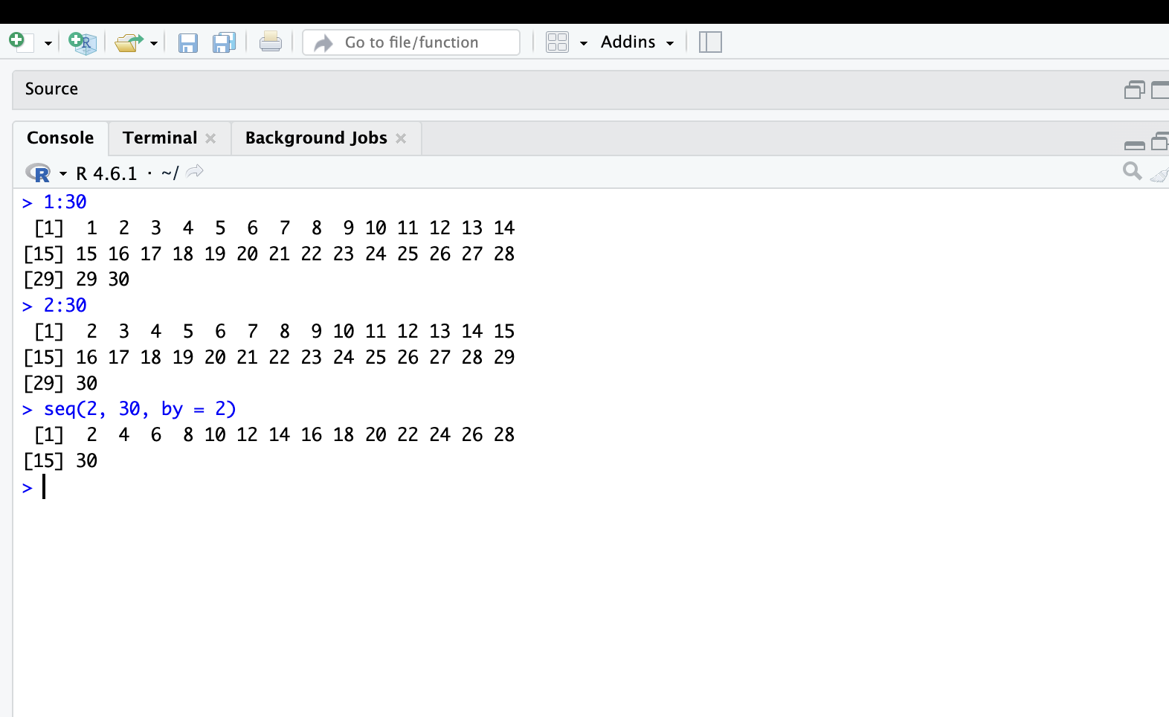
6. Reverse Sequence
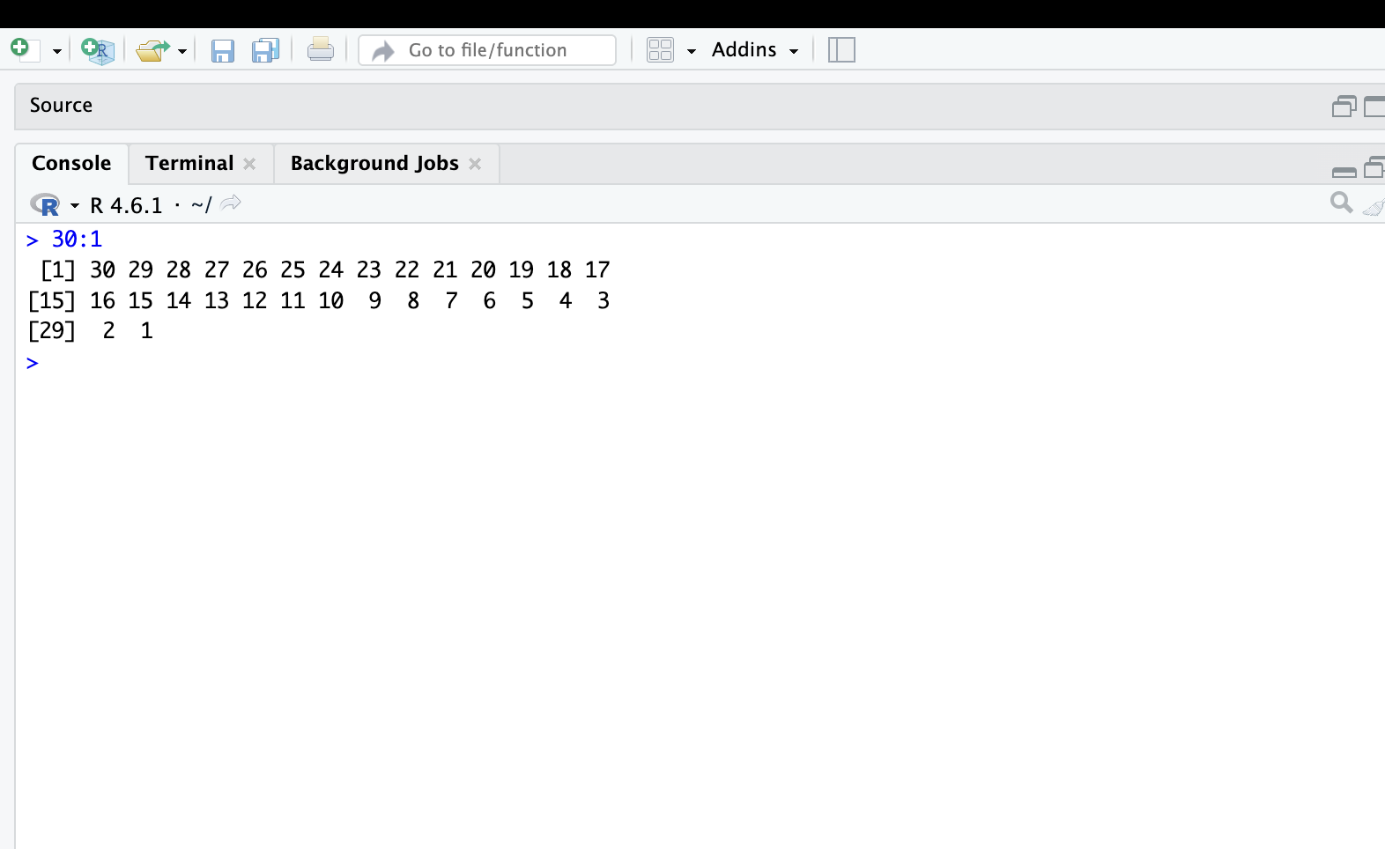
7. seq() Function
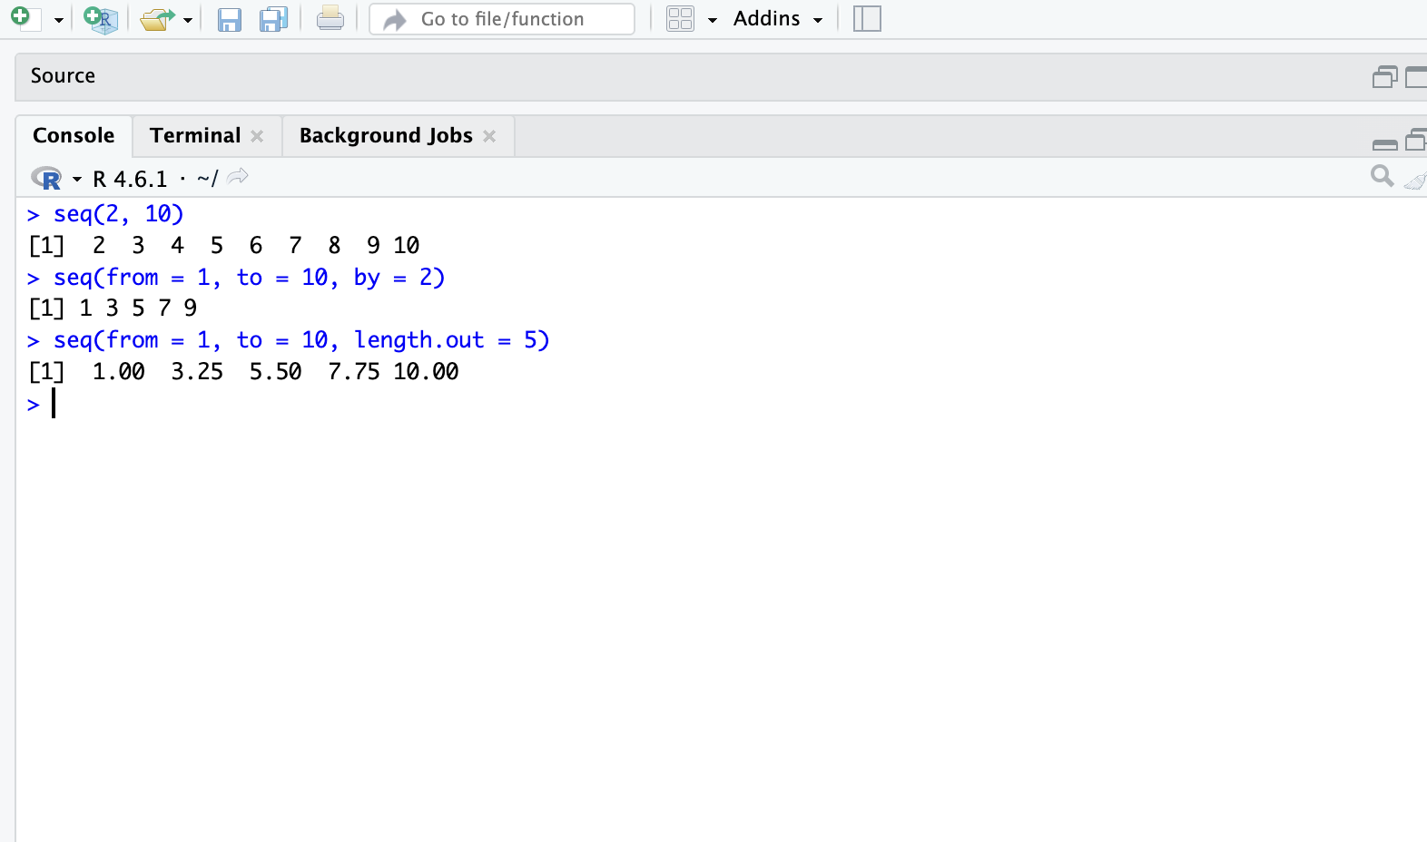
8. rep() Function
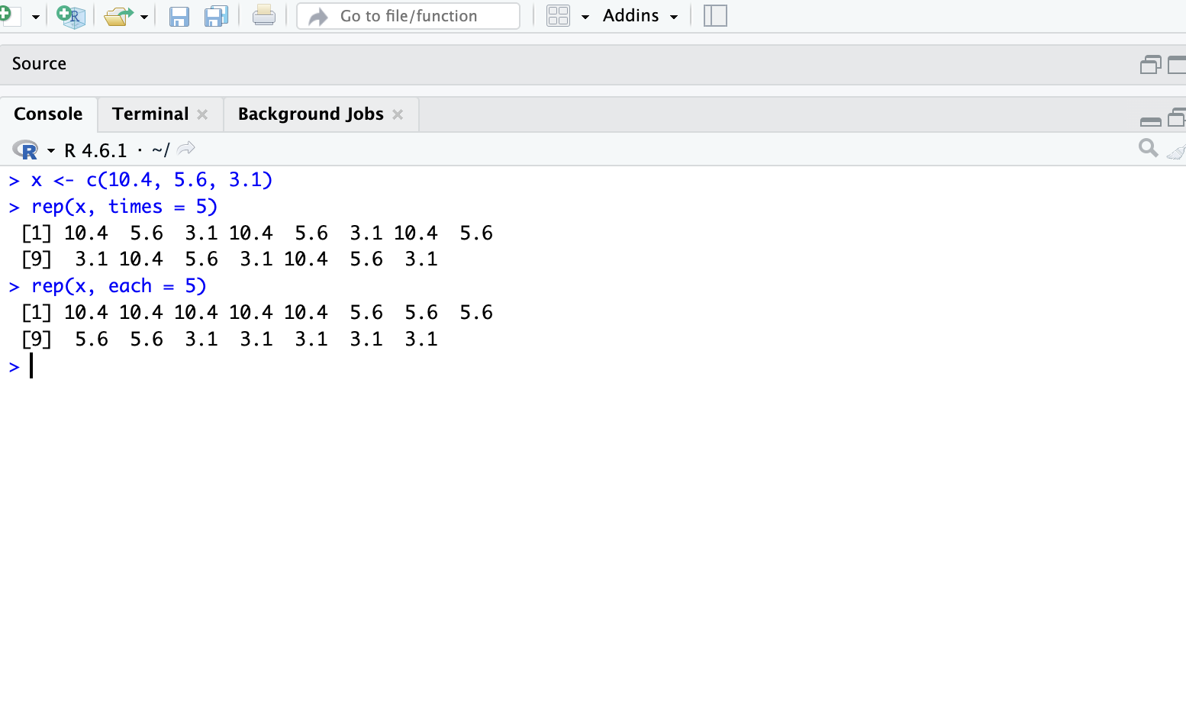

9. Logical Vectors
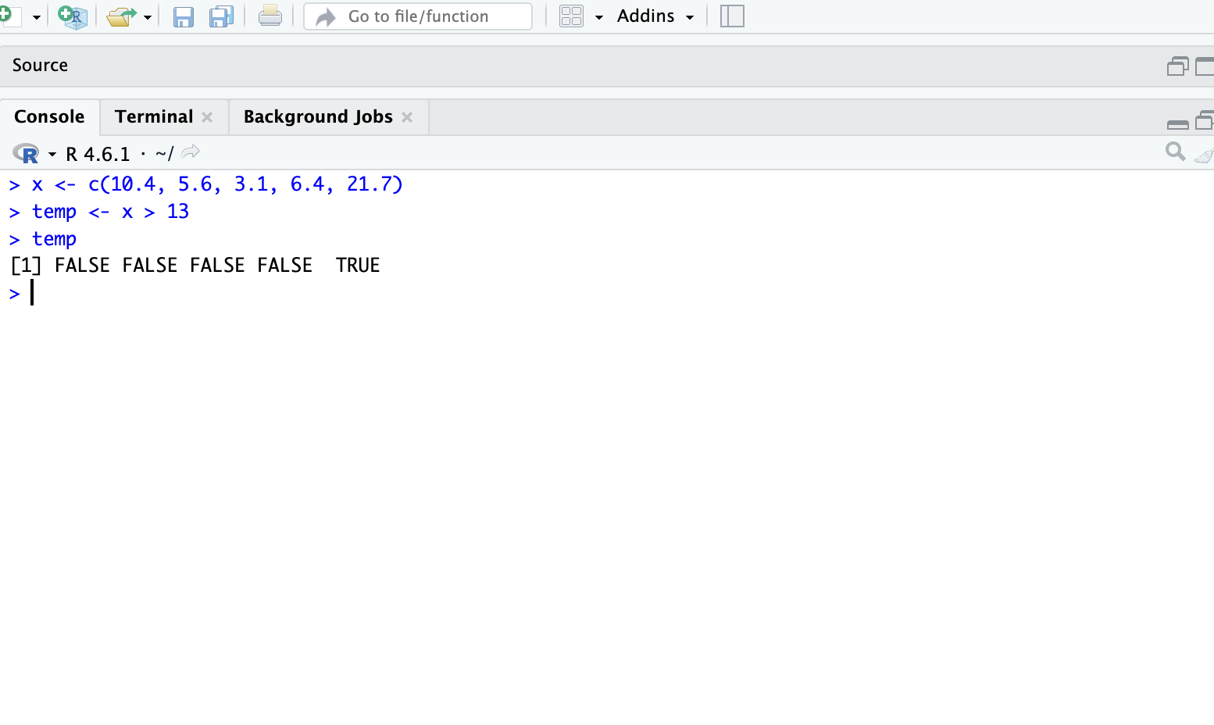
10. Logical Operators
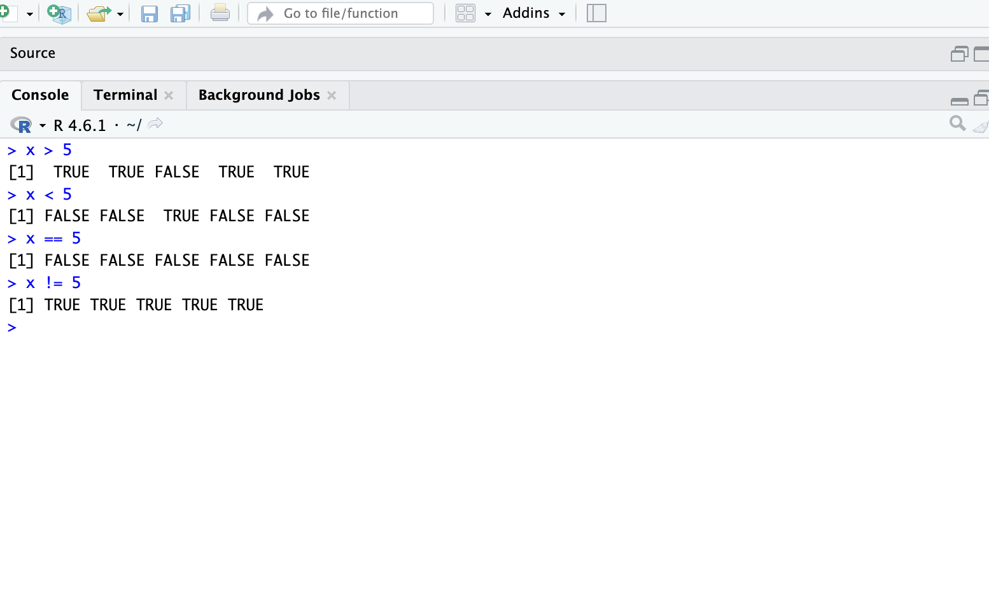

11. AND, OR, NOT
